Travel Devon – Travel Toolkit for Businesses
Business User Guide

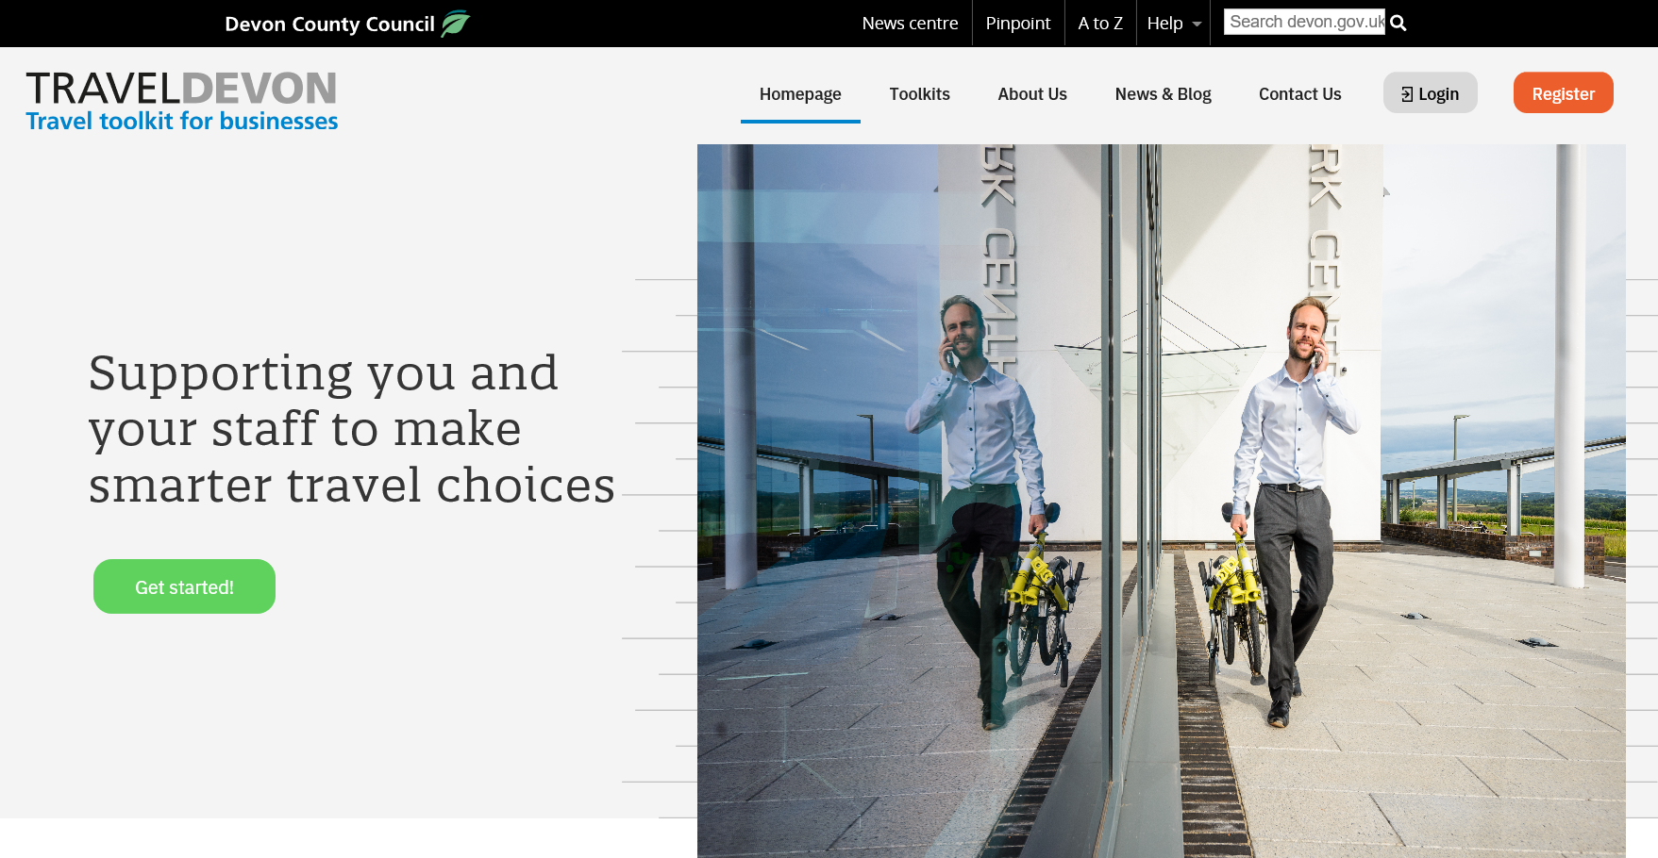
Content

This document will guide you through all the different functions of the new and improved Travel Devon – Toolkit for businesses (Travel Devon Toolkit).

- Registering and logging in
- Your business dashboard explained
- Managing your business account
  - Add/ manage sites
  - Add/ manage users
  - Accepting a user invitation

- Using the Travel Audit
  - Completing a Travel Audit
  - Downloading your Travel Audit certificate

- Using the Travel Survey
  - Starting a new Travel Survey
  - Sending out your Travel Survey to staff
  - Closing the Travel Survey and downloading raw data/ survey report

- Toolkits
  - Browsing our toolkits
  - Travel Plan template and guidance

PLEASE NOTE: Travel Devon Grants for Businesses are currently closed.

Please check the Travel Devon Toolkit for any updates on potential future grant funding opportunities.

- Registering and logging in

- To register your business on the Travel Devon Toolkit, visit www.traveldevontoolkit.info and click ‘Register’ (Image 1).

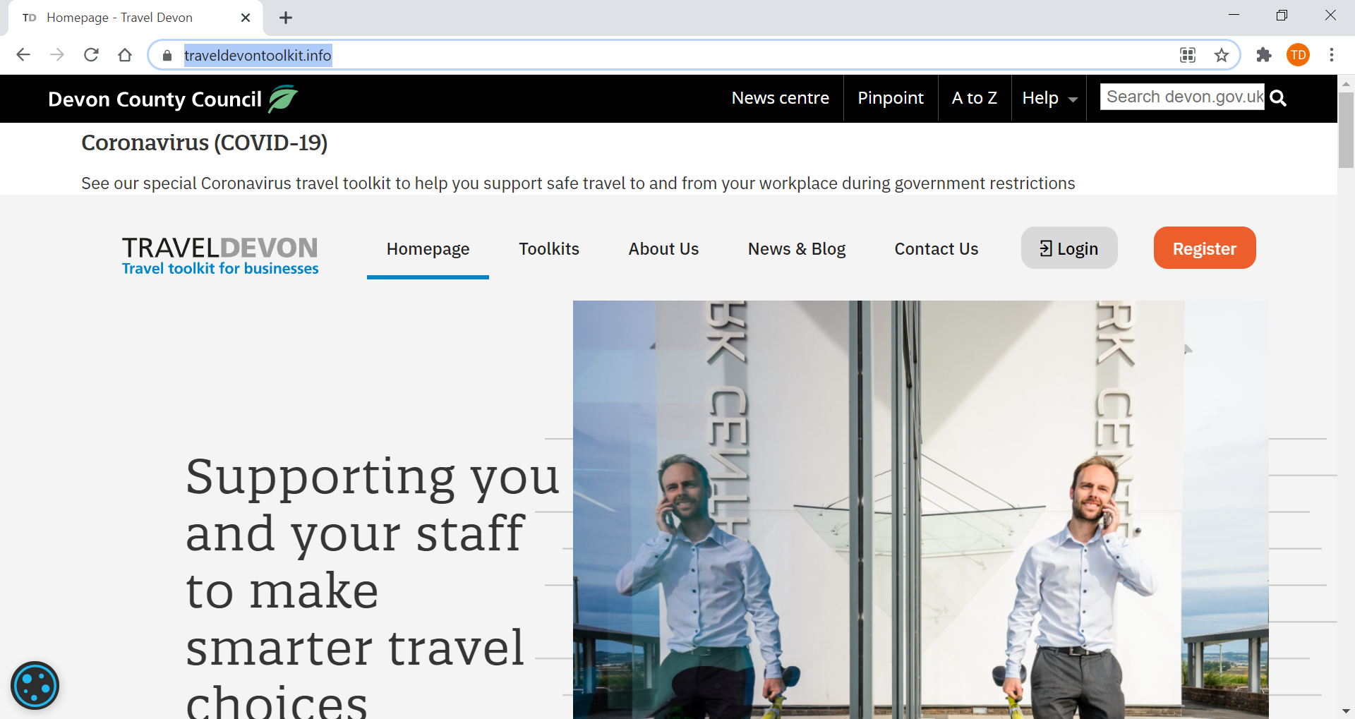
Image 1: Travel Devon Toolkit Homepage

- Fill out the form (Image 2, 3 and 4) and click ‘Submit’ (Image 4).

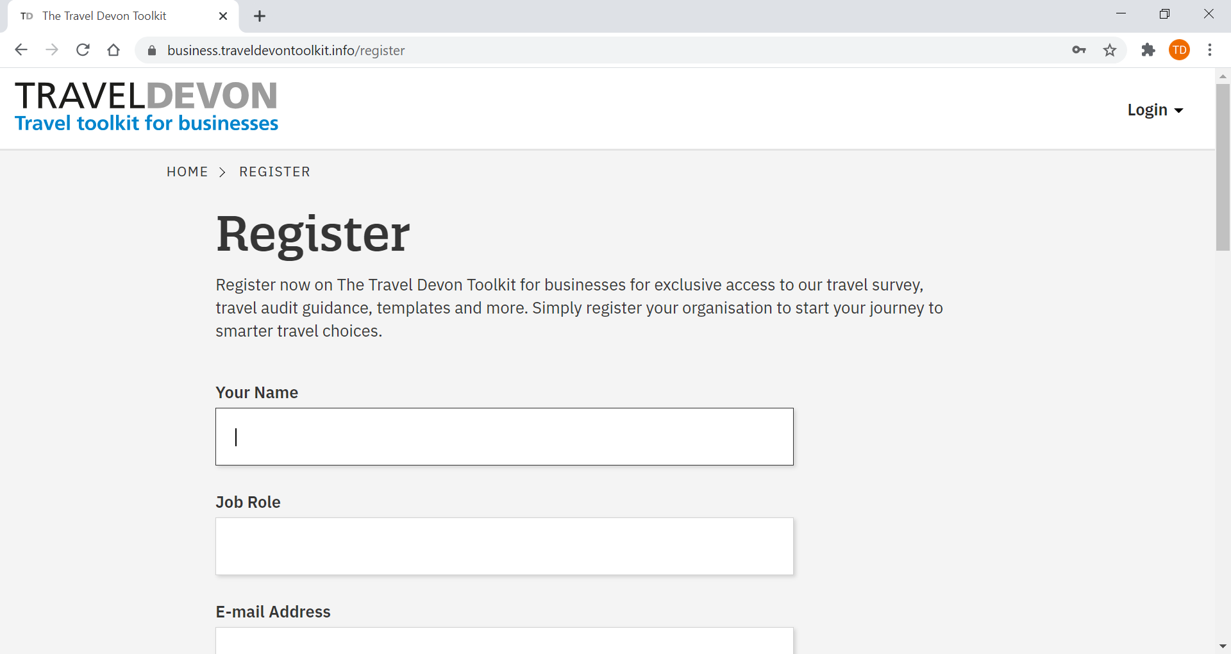
Image 2: Business registration form (1 of 3)

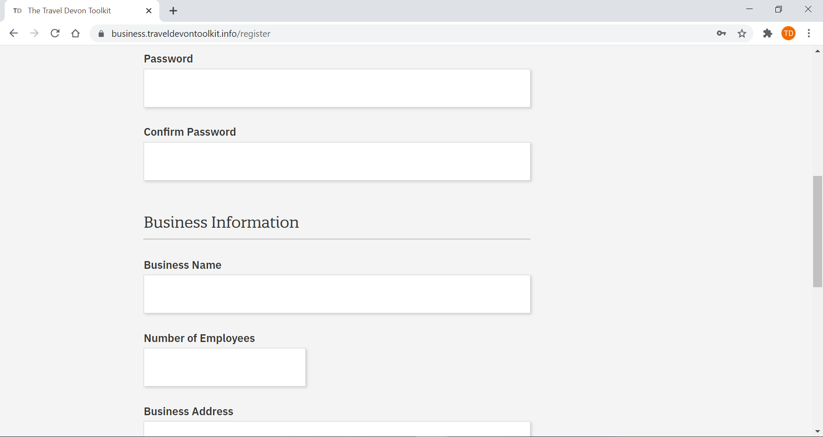
Image 3: Business registration form (2 of 3)

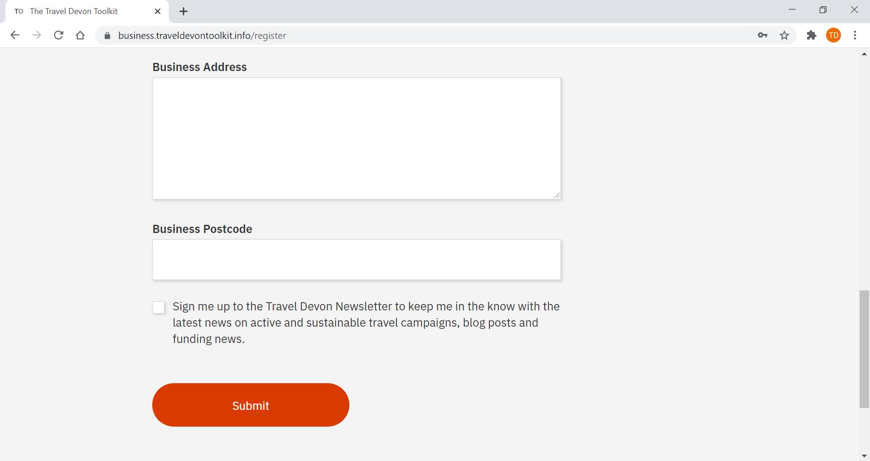
Image 4: Business registration form (3 of 3)

- After registering and submitting your details, you will receive an email asking you to verify your email address and login to the Travel Devon Toolkit website. Click the action button in the email (Image 5).

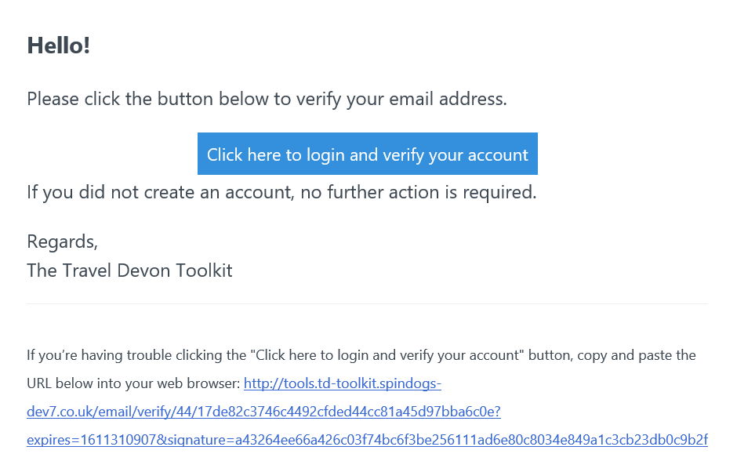
Image 5: ‘Click here to login and verify your account’ action button

Didn’t receive an email? Please check your spam or junk email. If you still cannot find the email, try to login with the login details that you have registered and request for another email to be sent.

If this still doesn’t work, please email Travel Devon at traveldevon@devon.gov.uk to request support.

- By clicking the action button in the email, you will be taken straight into the Travel Devon Toolkit website.

- The next time you would like to login, visit www.traveldevontoolkit.info and click ‘Login’. Use the login details you have just created to login. You can now start your journey towards smarter travel for your business.

Image 6: log into the Travel Devon Toolkit

- Your business dashboard explained

When you are logged in, you will see the Travel Devon: Travel toolkit for businesses dashboard for your business (Image 6).

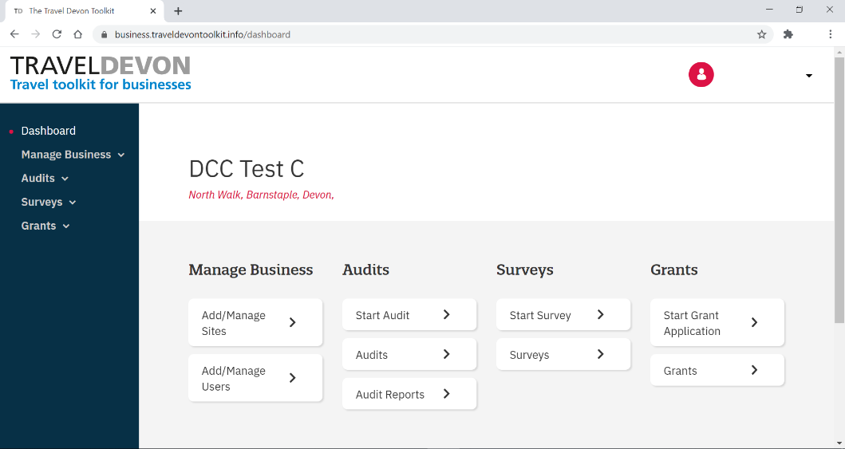
Image 7: Travel toolkit for businesses dashboard

As shown in Image 7, you can find the main menu on the left-hand side. From the main menu you can easily navigate to:
- Manage Business (Section 3);
- Audits (Section 4);
- Surveys (Section 5); and

You can also access this functionality via the quick access option in the grey section (Image 6).

PLEASE NOTE: Travel Devon Grants for Businesses are currently closed.

Please check the Travel Devon Toolkit for any updates on potential future grant funding opportunities.

- Managing your business account

Clicking ‘Manage Business’ allows you to manage your business account (Image 8).

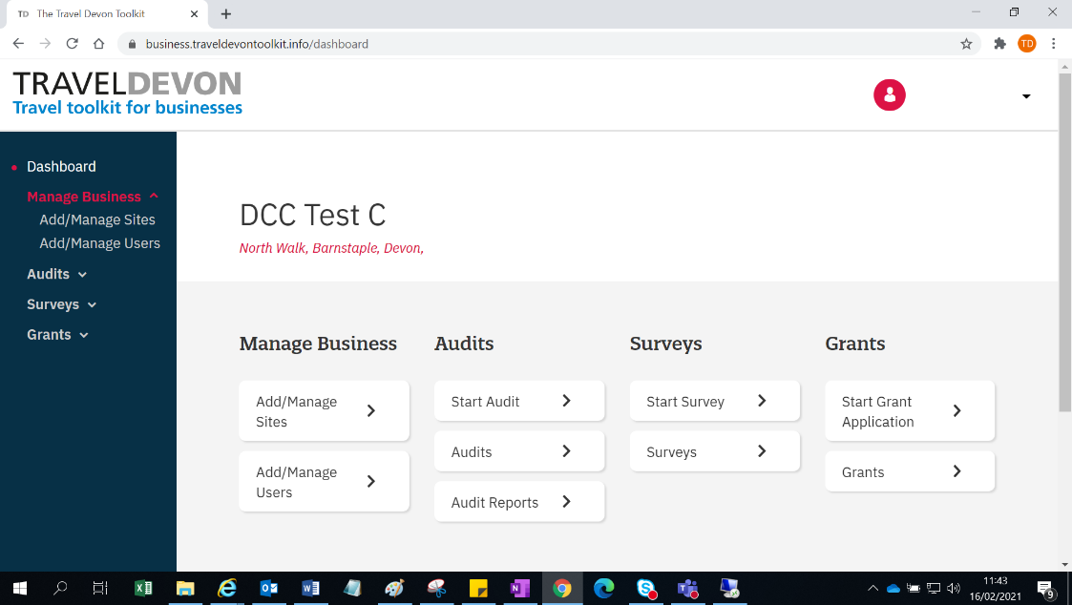
Image 8: Manage your business

There are two options:
- Add/Manage Sites; and
- Add/Manage Users.

  - Add/Manage Sites

The site and site address that you registered when you signed up to the Travel Devon Toolkit, is by default labelled as your ‘Headquarters’ (Image 9).

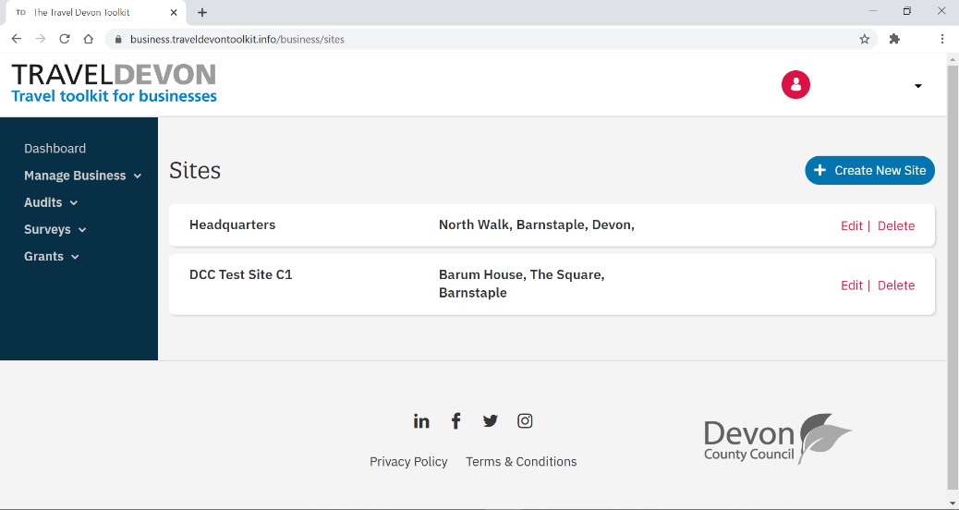
Image 9: Headquarters

By clicking ‘Add/Manage Site’ you can create additional sites (Image 10). This could be useful if your business has multiple sites and will enable you to create Travel Surveys and complete Travel Audits for each individual site or edit the details of each site.

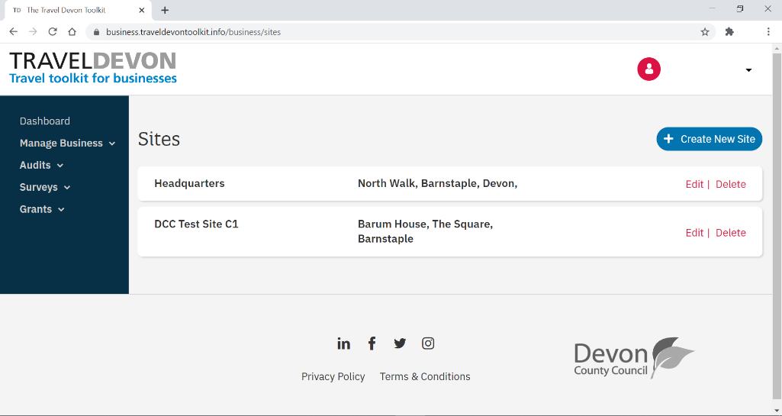
Image 10: Additional sites

    - To add a new site:

- Click ‘Manage Business’
- Click ‘Add/ Manage Sites’
- Click ‘Create new site’
- Fill out all the details:
  - Site name
  - Number of employees per site
  - Site address
  - Site postcode (PLEASE NOTE: without a site postcode, our Travel Survey Tool will not work fully)
- Click ‘Save’

You have now created a new site against your business. A notification will pop up at the top of the dashboard stating, ‘Site creation successful’ (Image 11).

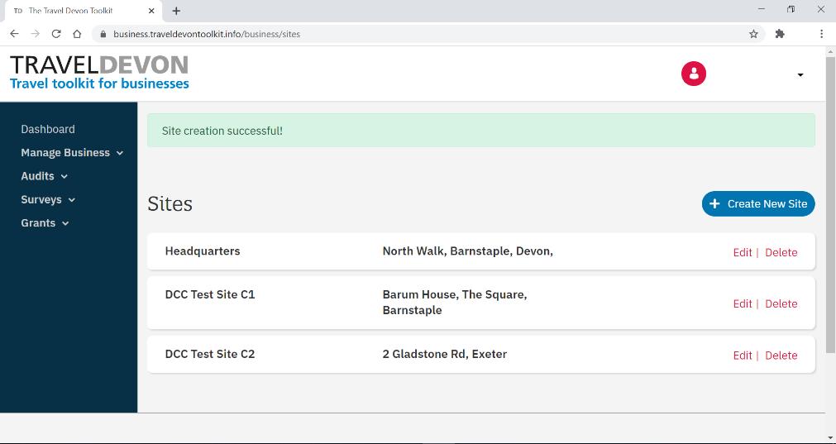
Image 11: Site creation successful!

    - To edit a site:
- Click ‘Manage Business’
- Click ‘Add/ Manage Sites‘
- Click ‘Edit’ for the site you wish to edit
- Update the sites details
- Click ‘Save’

Your site details have now been updated. A notification will pop up at the top of the dashboard, stating ‘Site successfully updated’ (Image 12).

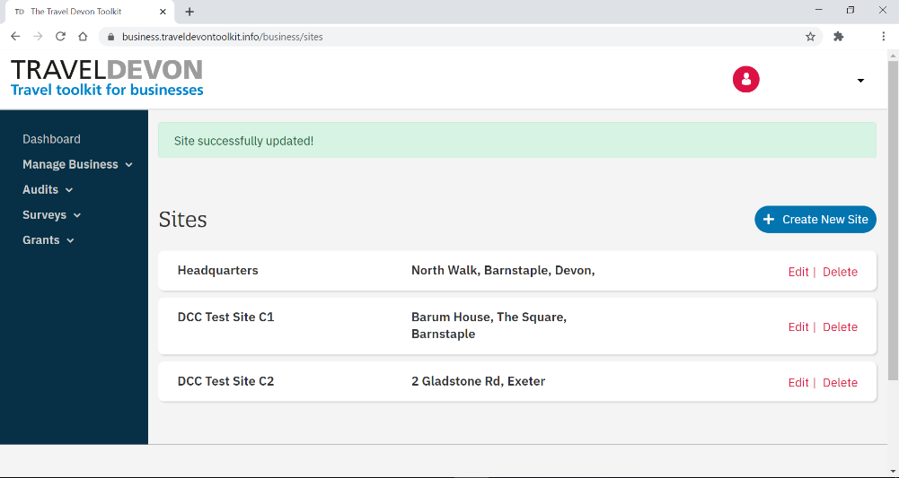
Image 12: Site successfully updated

    - To delete a site:
- Click ‘Manage Business’
- Click ‘Add/ Manage Sites‘
- Find the site in the list and click ‘Delete’.

PLEASE NOTE: once you click ‘Delete’ the site will be deleted straight away. You will not get a warning asking to confirm your choice. Once a site is deleted it can not be recovered and you will not be able to access any historic data for this site.

You can contact Travel Devon via traveldevon@devon.gov.uk to request any raw data from the travel audit or survey.

  - Add/Manage Users

The Add/Manage Users section allows you to invite a colleague as an additional user for your business account. This could be useful when others need access the business account e.g. to complete a Travel Audit or create a Travel Survey for their site.

    - To invite a new user:
- Click ‘Manage Business’
- Click ‘Add/ Manage Users’
- Click ‘Invite user’
- Fill out their name, job role and email address (Image 13)

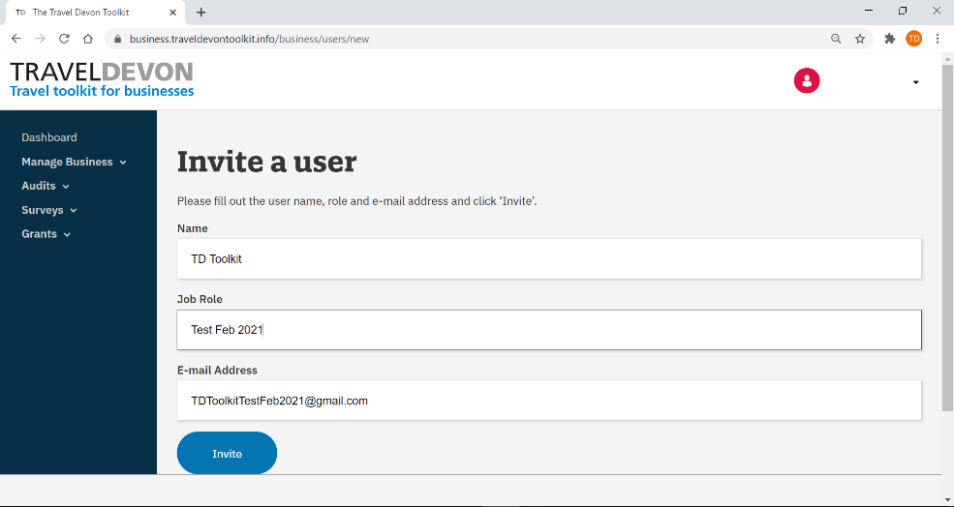
Image 13: Invite a new user

- Click ‘Invite’

A notification will pop up at the top of the dashboard, stating ‘User was successfully invited’ (Image 14).

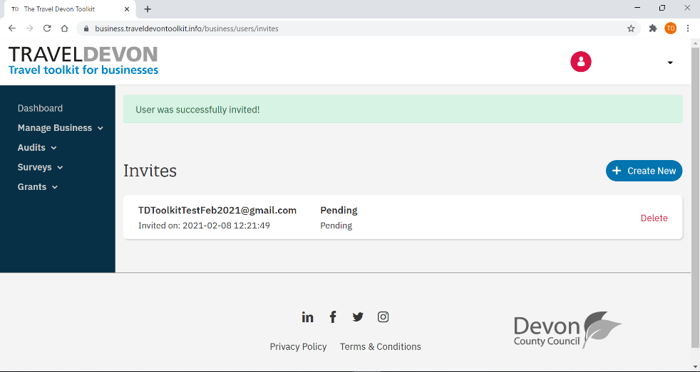
Image 14: User was successfully invited

Your colleague or member of staff will receive an email notifying them that they have been invited to the Travel Devon Toolkit by you.

If the person you invited hasn’t received the invitation via email, please ask them to check their spam or junk inbox.

If they still cannot find the email, please try to resend the invitation.

If this hasn’t worked, please email Travel Devon at traveldevon@devon.gov.uk for support.

  - Accepting a user invitation

Before a new user can access the Travel Devon Toolkit, they will need to accept the user invitation. The user invitation will be sent to their email address (Image 15).

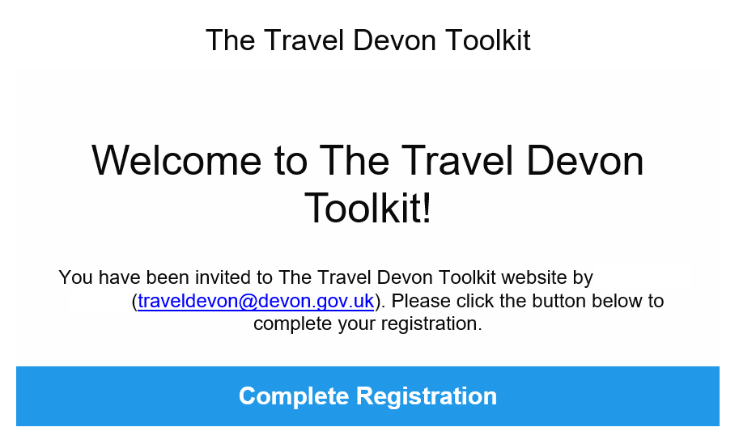
Image 15: User invitation

  - Open the email invitation. This confirms who has invited you. Please note: the name in Image 15 has been deleted for privacy reasons.

If you cannot find the email, please check your spam or junk inbox.

If you still can’t find the email, please ask your admin to resend the invitation.

If this doesn’t work, please email Travel Devon at traveldevon@devon.gov.uk.

  - In the email, click ‘Complete registration’ (Image 15). You will be taken to the Travel Devon Toolkit website (Image 16 and 17) to complete your registration by filling out your name and creating a password of your choice.
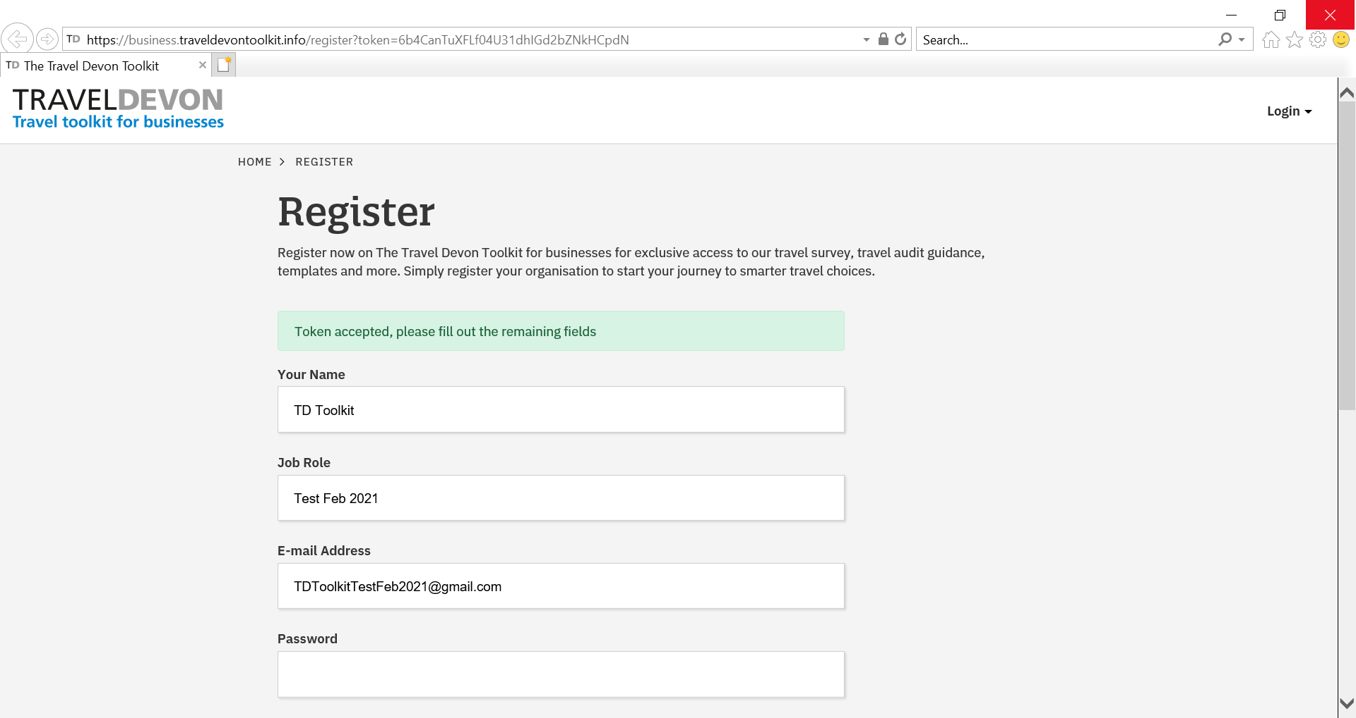
Image 16: Completing your registration (1 of 2)

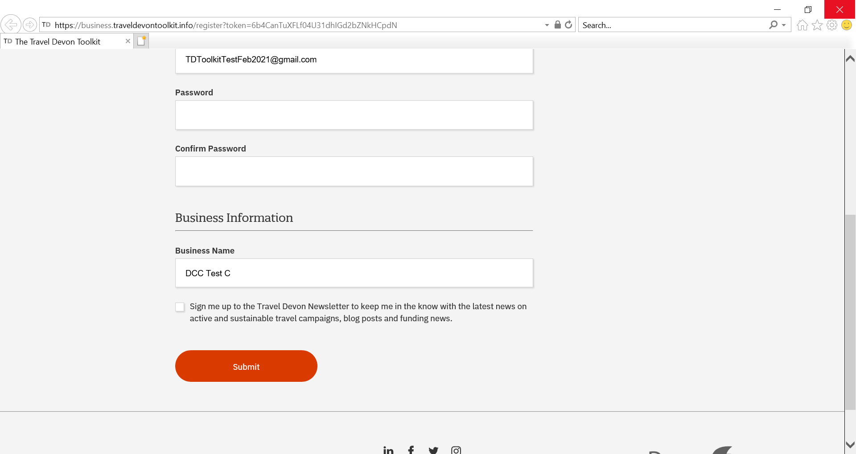
Image 17: Completing your registration (2 of 2)

  - Click ‘Submit’ to complete the process.
  - You can now login on the Travel Devon Toolkit using the login details you have just created (Image 18).

Image 18: Login to the Travel Devon Toolkit

- Using the Travel Audit

Our Travel Audit is the first step in making your business an industry leader in green and sustainable travel. The audit gives you an idea of how well your business currently supports sustainable and active travel by giving your site a score of bronze, silver, gold or platinum, based on your answers.

The audit report that is automatically generated for you and provides a clear direction on areas to improve by proving links to further tips and guidance.

You can access the Travel Audit tool from your business dashboard (Image 19). It allows you to start new audits (e.g. for different sites), continue saved audits and view and download audit results and reports.

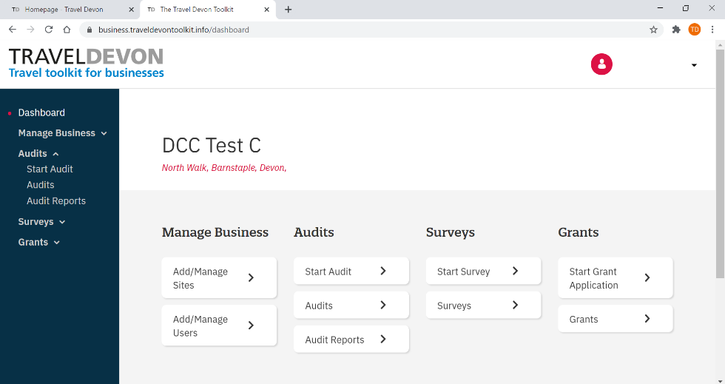
Image 19: Accessing the Travel Audit

  - Completing a Travel Audit
- Click ‘Audits’
- Click ‘Start Audit’

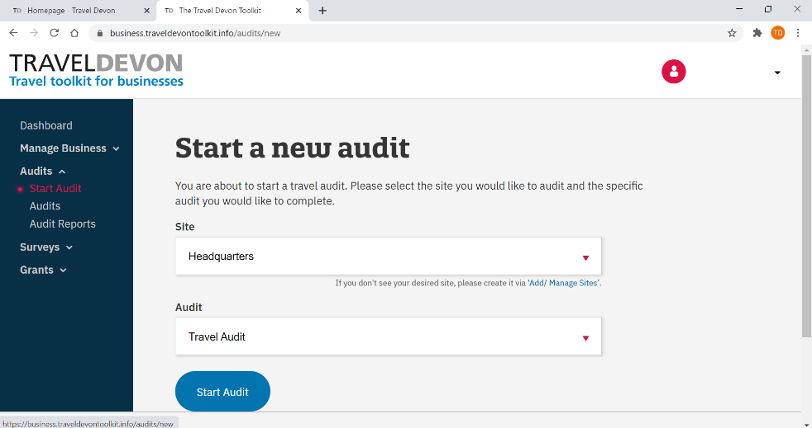
Image 20: Start a new audit

- Site (Image 20): select the site you would like to complete an audit for from the dropdown list. See section 3.1, on how to add sites to your business account.
- Audit (Image 20): select ‘Travel Audit’ from the dropdown list
- Click the blue ‘Start Audit’ button
- There are 5 sections in total. For each section, answer all the questions by clicking the ‘Yes’ or ‘No’ option (Image 21).

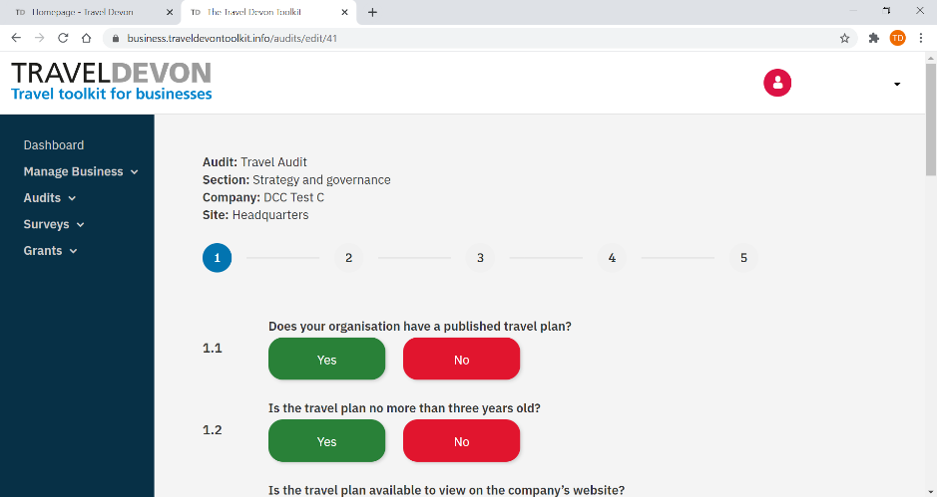
Image 21: Answering audit questions

The answers you have selected will appear bolder and will have a black outline (Image 22).

- You can save your progress after completing a section. Click ‘save and continue’ (Image 22) to save your progress and move to the next section.

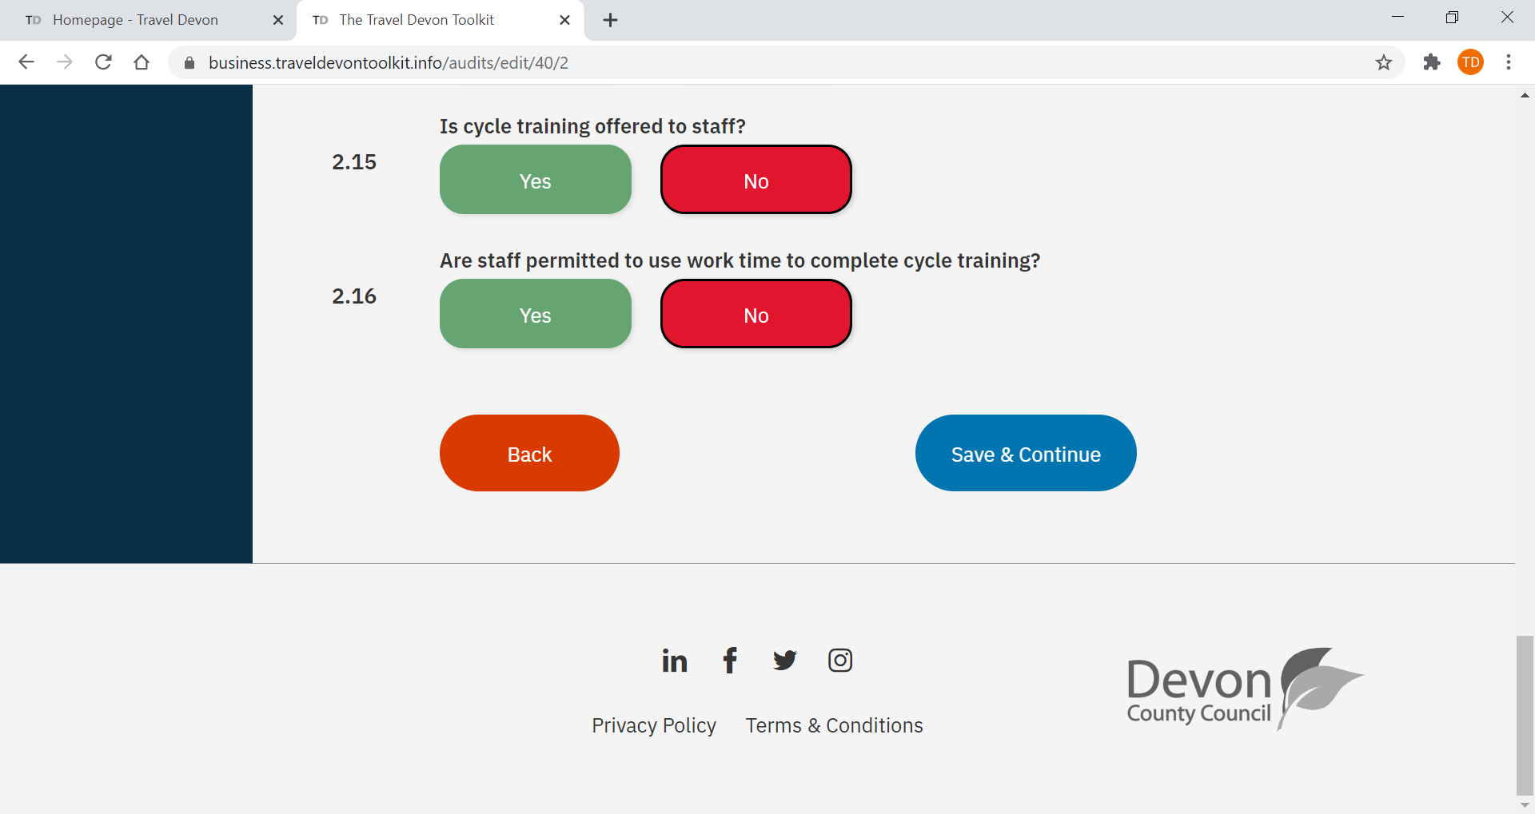
Image 22: Answer selection and Save & Continue

  - If you exit the Audit, you can continue completing it by clicking:
    - Audits (Image 23)
    - Audits (Image 23)

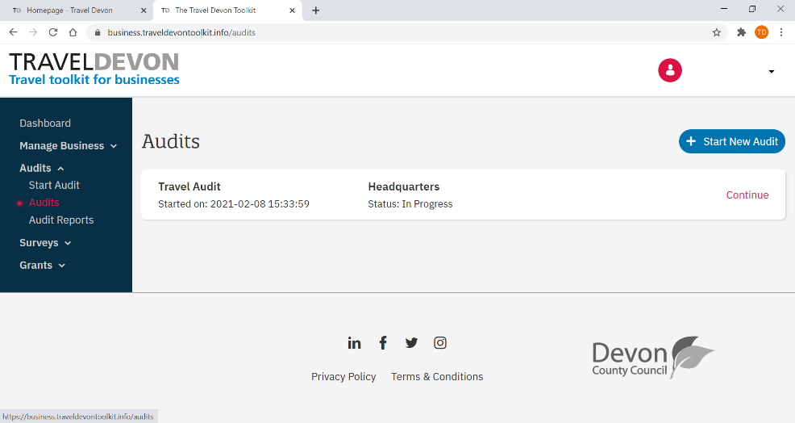
Image 23: Continuing an audit in progress (1 of 2)

    - Click ‘Continue’ for the audit you want to complete (Image 24).

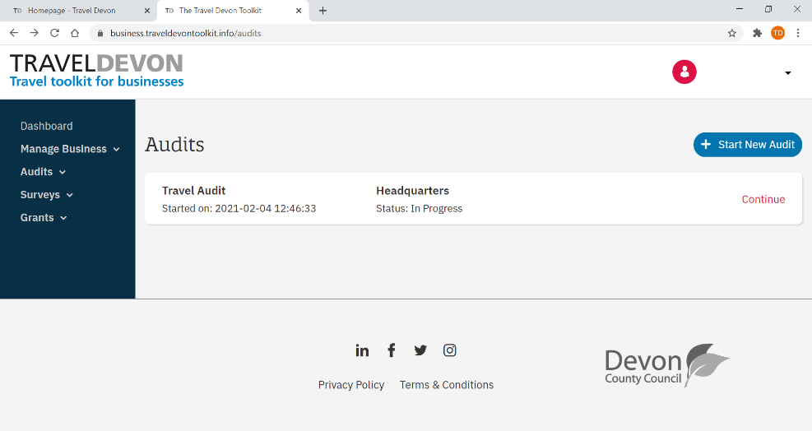
Image 24: Continuing an audit in progress (2 of 2)

- After completing all sections, click ‘Complete audit’ to submit all your answers
- Once the audit is completed and submitted, you will be taken to a bespoke Travel Audit Report page giving you immediate access to your results. By scrolling down the webpage, you can view your businesses audit results and read any tips or guidance providing a clear direction on areas to improve.

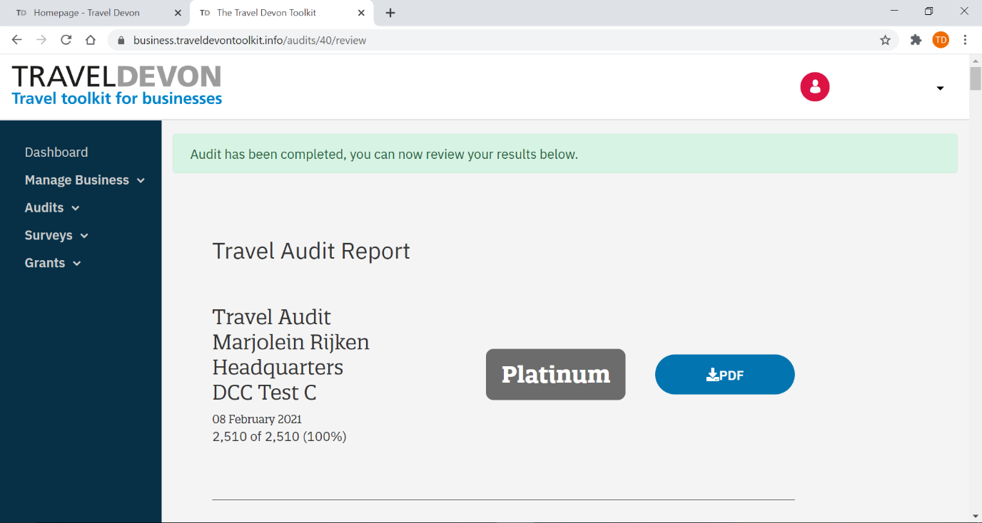
3
2
1
Image 25: Travel Audit Report

You can find your score underneath the report date (Image 25, 1).

The report will also state whether your business scored Bronze, Silver, Gold or even Platinum (Image 25, 2). If your score was under the minimum score for Bronze, your report will state ‘Ungraded’.

Alternatively, you can download a PDF version of your report by clicking the ‘PDF download’ button (Image 25, 3).

  - Downloading your travel audit certificate

- Click ‘Audits’
- Click ‘Audit reports’
- Find the audit from the list and click ‘certificate’ on the right-hand side (Image 26).

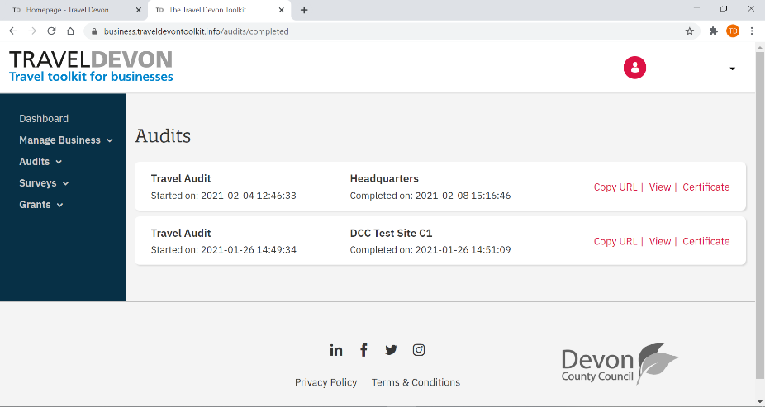
Image 26: Travel Audit Certificate

- Your travel audit certificate will start downloading.

- Once you have downloaded the audit certificate (Image 27), you could display it on a staff information board to showcase how well you performed.
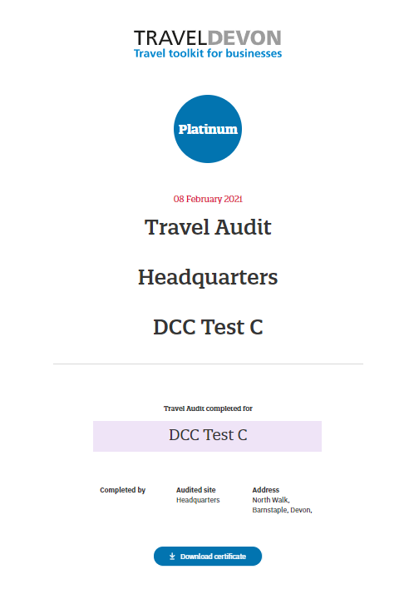
Image 27: Travel Audit Certificate
- Using the Travel Survey

Find out exactly how your staff currently travel to your business and any barriers to smarter travel with our Travel Survey. This will help you provide the most appropriate support and enable your staff to choose sustainable and active travel alternatives.

A Travel Survey Report is automatically generated for you after you close the survey, giving you direct insight into travel patterns and what could help you shift these towards smarter travel.

You can access the Travel Survey tool from your business dashboard (Image 28). It allows you to create surveys and copy a URL to help your send out the survey to colleagues. After you have received all responses, you can view your survey results and download your survey reports.

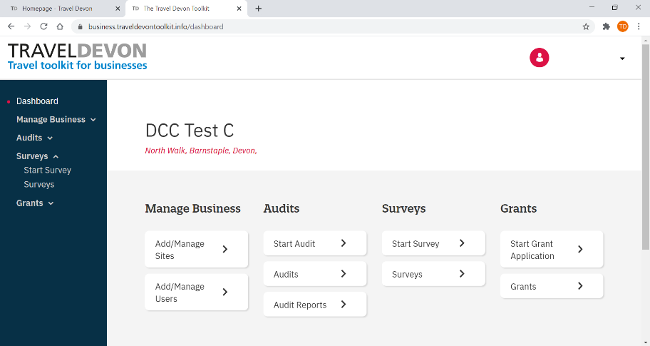
Image 28: Accessing the Travel Survey

  - Starting a new Travel Survey

- Click ‘Surveys’
- Click ‘Start survey’

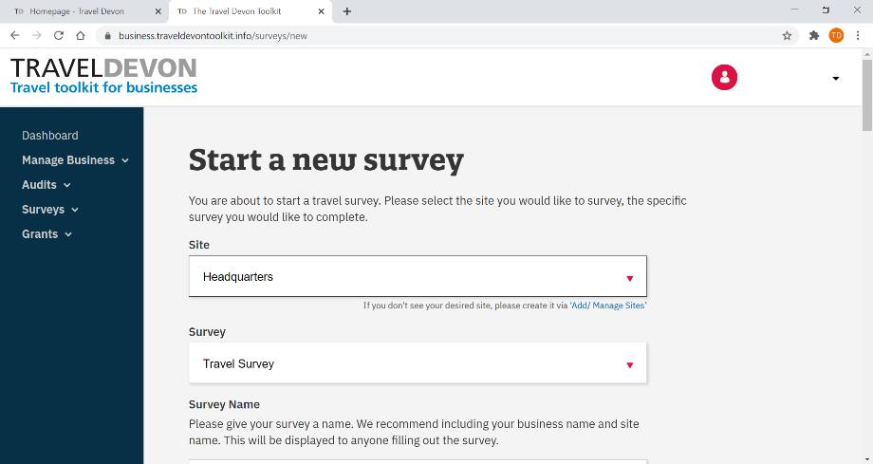
Image 29: Start a new survey (1 of 2)

- Site (Image 29): if you have more than one site (See section 3.1, on how to add sites to your business account) you will need to select which site you would like to start a travel survey for. You can select the site from the dropdown list.
- Survey (Image 29): select ‘Travel Survey’ from the dropdown list.
- Survey name (Image 30): give your survey a name. We recommend including your business name and site name, as this will be displayed to anyone filling out the survey.

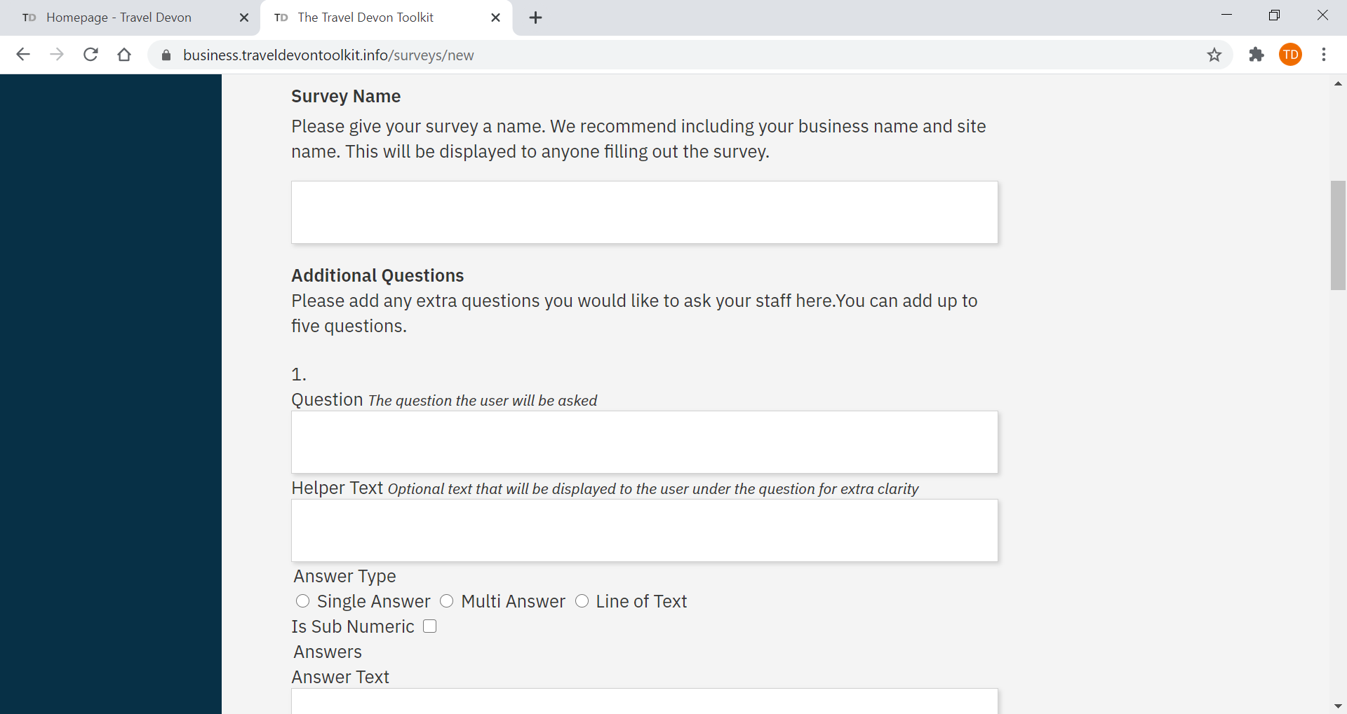
Image 30: Start a new survey (2 of 2)

- Additional questions (Image 31): The travel survey allows you to add specific questions that are relevant for your workplace. You can add up to 5 additional questions in a Single Answer, Multi Answer or Line of Text format. If you do not wish to add any questions, you can just proceed with step 7.
  - To add multiple answer options for Single Answer and Multi Answer questions, click ‘Add Answer’ (Image 31).

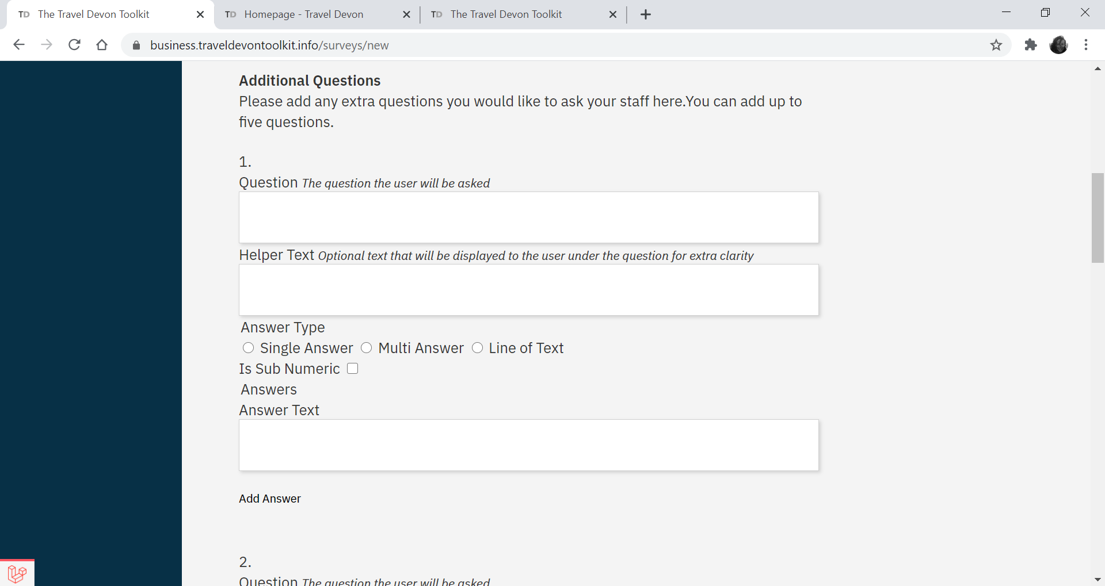
Image 31: Adding an answer option

- Click ‘Create’ (Image 32). The three action buttons pictured in Image 31 will appear at the bottom of the page:
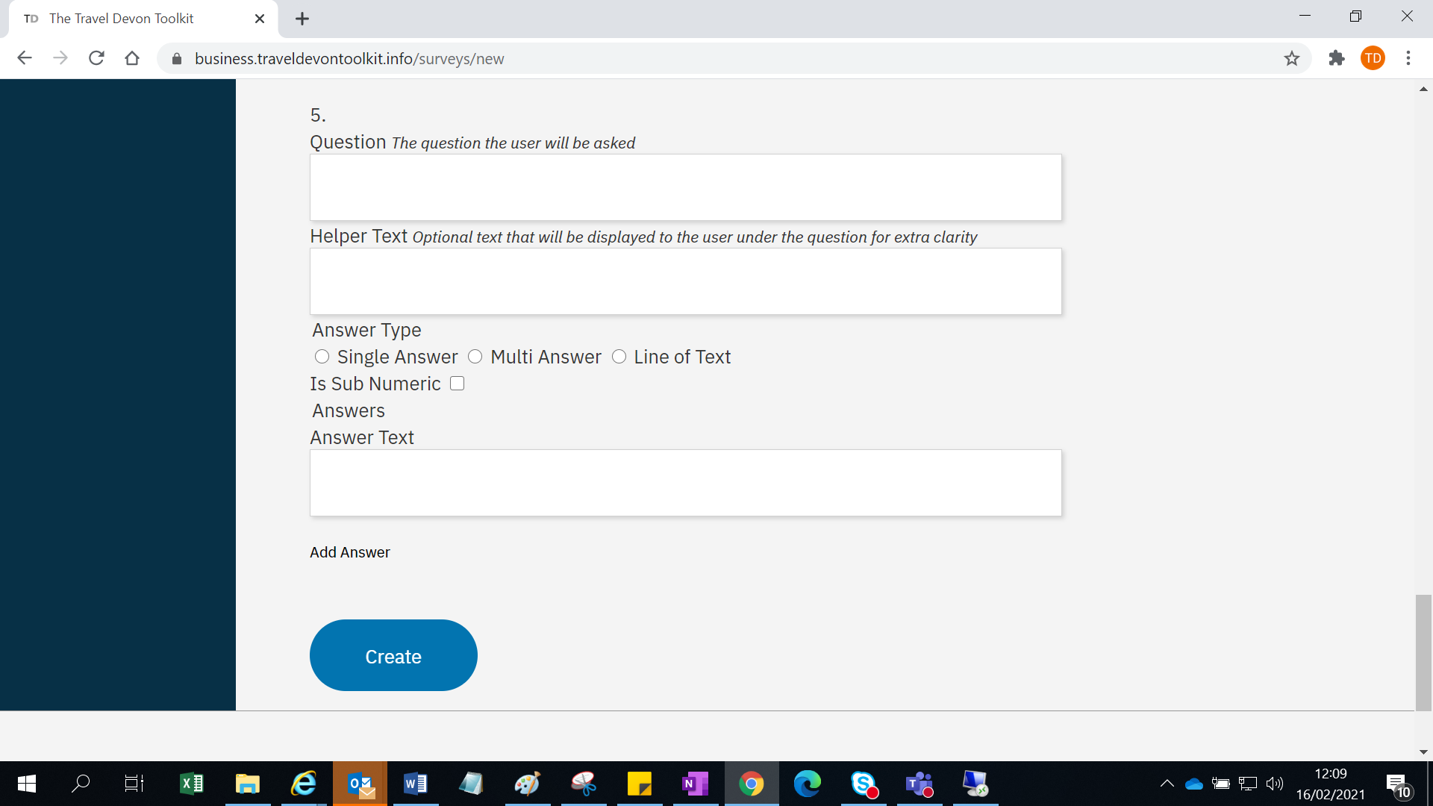
Image 32: Creating a Travel Survey

  - You can still make any changes to the setup of the survey. Click ‘Save’ to save the changes you have made (Image 33).
  - Click ‘Preview’ to see what the survey will look like (Image 33)
    - PLEASE NOTE: to make final changes: in the main menu, click ‘Surveys’ and again ‘Surveys’ and select ‘Edit’ for the survey you would to make changes
  - Click ‘Publish’ if you are happy with the survey and it is ready to be sent out (Image 33).

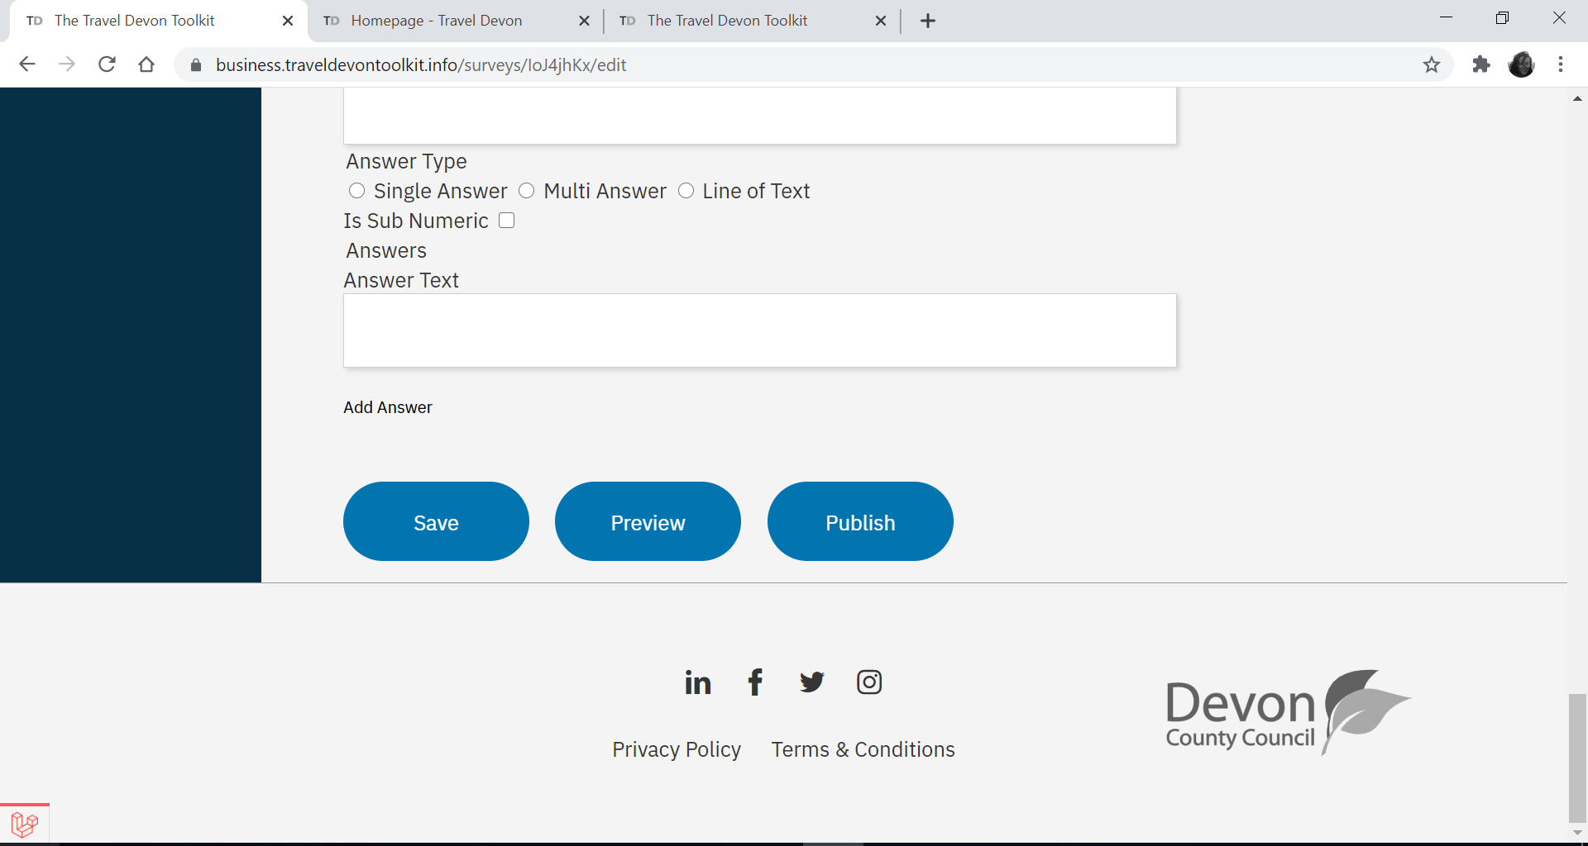
Image 33: Creating, saving, previewing and publishing a Travel Survey

    - Publishing the survey takes you to a list of surveys that have been created against the business. The status of your survey should now say ‘Open’ (Image 34).

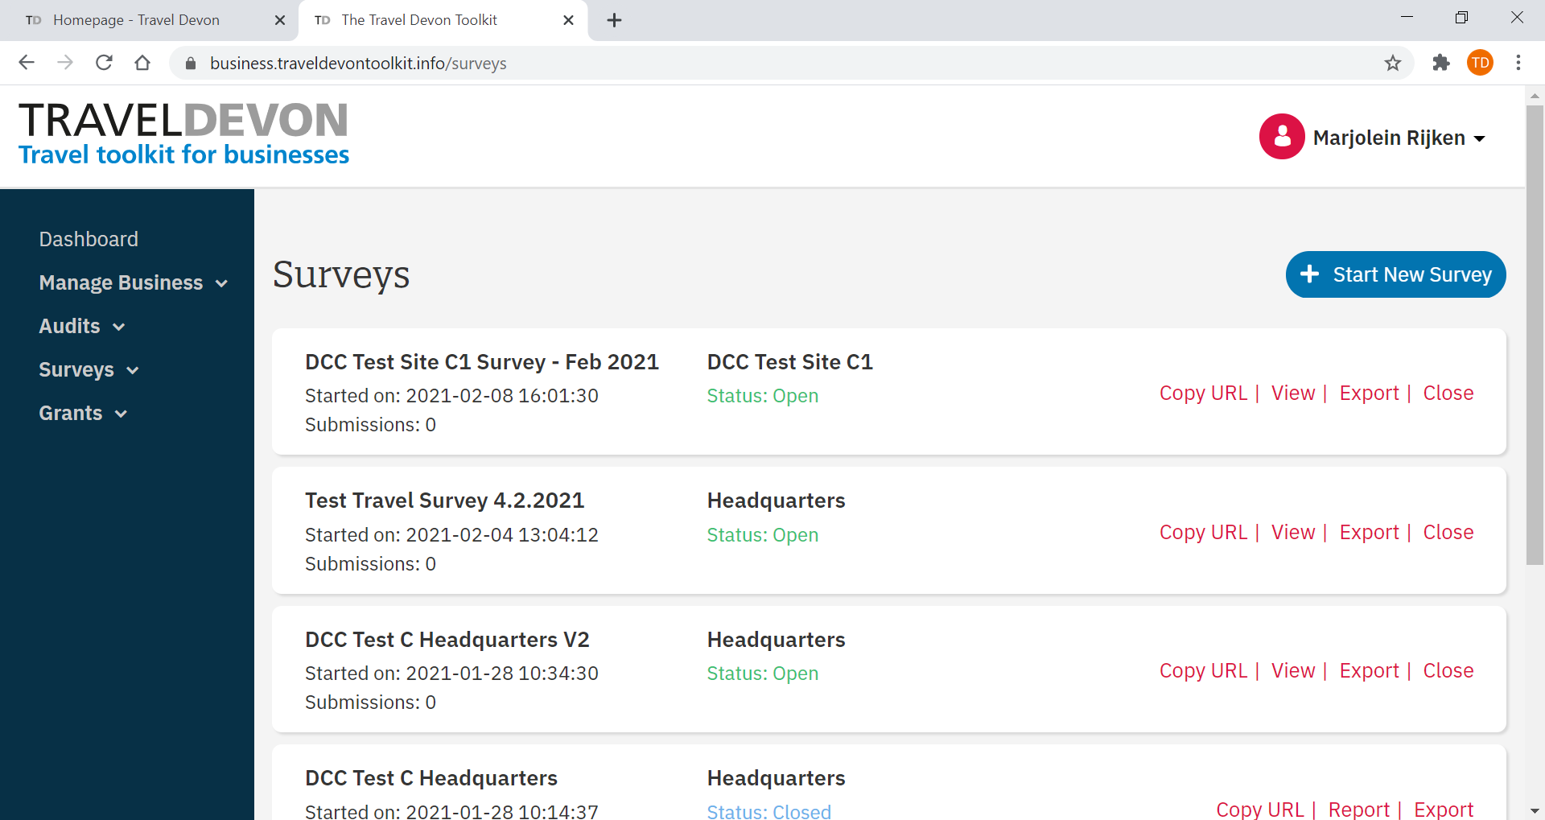
Image 34: Survey status ‘Open’

  - Sending out your Travel Survey to staff
After creating your Travel Survey and publishing it, you can easily circulate the survey to staff:

- Click ‘Surveys’ (Image 35, 1)
- Click ‘Surveys’ (Image 35, 1)
- For the survey you just created (this one should be at the top), click ‘Copy URL’ (Image 35, 2).
- You can paste the URL in an email to all your colleague or staff.

PLEASE NOTE: Please ensure you have published your survey first and the status for your survey states ‘open’ (Image 27). If the status still says ‘Draft’, any responses that have been submitted will not be saved.

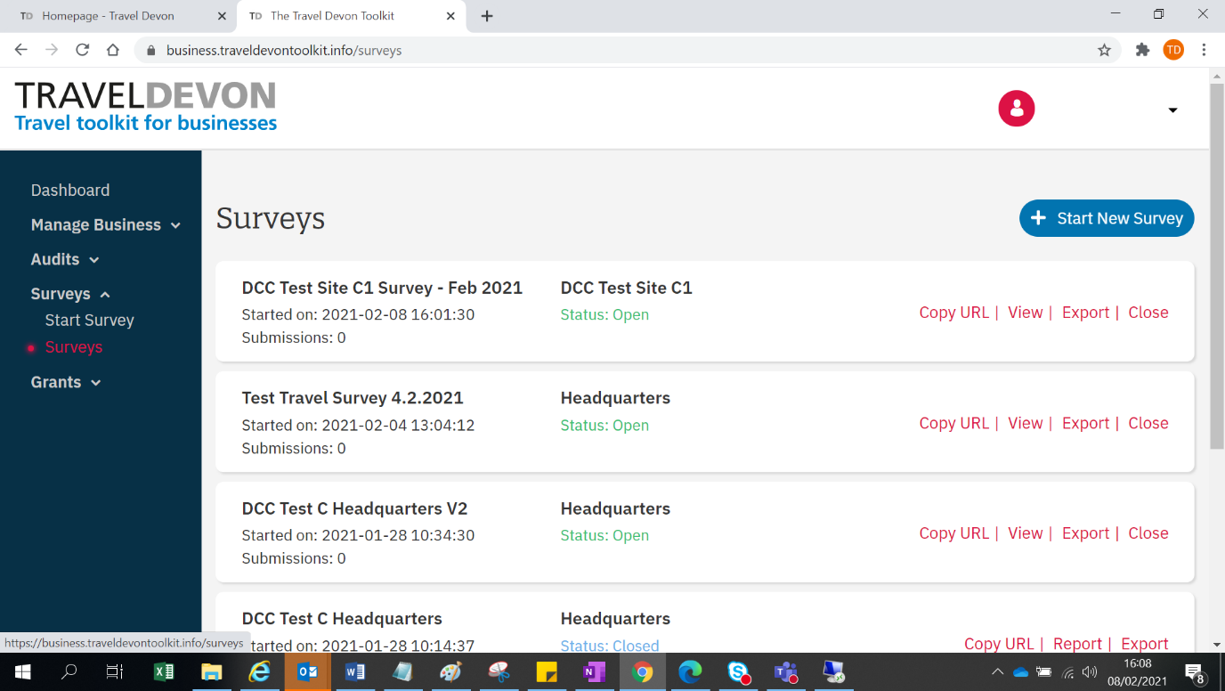
2
1
Image 35: Copying your survey URL

  - Closing the Travel Survey and downloading raw data/ survey report

It is highly recommended that you set a deadline by which you would like your staff or colleagues to complete the survey. Make sure you allow for some extra time to send a couple of reminders. Once you are happy with the number of responses:

- Click ‘Surveys’ (Image 36, 1)
- Click ‘Surveys’ (Image 36, 1)
- Click ‘Close’ for the survey you would like to close (Image 34, 2). Once closed, no additional data will be collected.

2
1
Image 36: Closing your Travel Survey

- To download your Travel Survey report, click ‘Report’ (Image 37). This will automatically generate a bespoke report and provide you with the key results from your travel survey.
- To download all the raw data to do your own data analysis, click ‘Export’ (Image 37). A CSV file containing the raw data will start downloading.

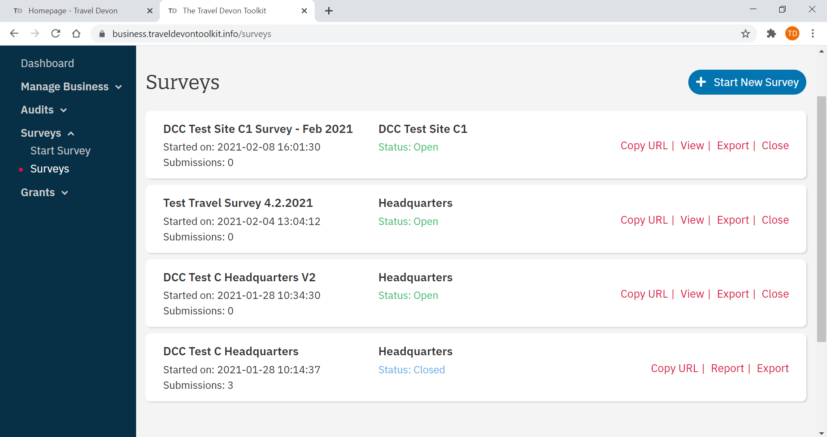
Image 37: Downloading your Travel Survey report and Exporting your Travel Survey data.

- Toolkits

Travel Devon toolkits are full of all the practical information you need to help you and your colleagues to make smarter travel choices.

Whether that’s getting more of your colleagues cycling to work, including public transport for part of their journey, or understanding how better driving practices can impact our environment, there are plenty of resources available.

You can use this information to develop a comprehensive travel plan for your organisation, or just use a few of our toolkits to promote specific alternative methods to travel – whatever suits your organisation best.

  - Browsing our toolkits

- Visit www.traveldevontoolkit.info/toolkits/
- Browse any section by selecting it from the tab menu on the left.
- To check out an individual toolkit, simply click ‘view’ and the toolkit will open in a new window
- To download a specific toolkit, click ‘Download as PDF’.

  - Travel plan template and guidance

Once you have completed the Travel Audit and Travel Survey, you can start writing a Travel Plan for your business site(s). To help you get started, please see our ‘Creating a Travel Plan’ toolkit.

